DESIGN AND DEVELOPMENT OF AI DRIVEN E NOSE SYSTEM FOR FOOD QUALITY ANALYSIS IN APPLE
Kotapati Venkata Sasi Kiran Reddy ^{[1]}, Yeruva Maheswara Reddy ^{[2]}, Yakkanti Venkata Sri Charan reddy^{[3]}, E.D. Kanmani Ruby ^{[4]}
Kotapatisasikiran143@gmail.com ^{[1]}, maheswarareddyyeruvaofficial@gmail.com ^{[2],} charanyakkanti4355@gmail.com^{[3]}, dredkanmaniruby@veltech.edu.in^{[4],}

^{1,2,3} UG Student, Department of Electronics and Communication Engineering
⁴Professor, Department of Electronics and Communication Engineering
Vel Tech Rangarajan Dr. Sagunthala R&D Institute of Science and Technology,Chennai, India

Abstract— This research paper explains the food spoilage is a significant problem in the food industry, causing significant economic losses and posing health risks to consumers. One common type of food spoilage is the decay of fresh fruits such as apples, which can be caused by a variety of factors, including microbial growth, physical damage, and exposure to oxygen. In this project, we propose the use of artificial intelligence (AI) to develop a system for the detection of fresh and rotten apples in the food industry. The system will use machine learning algorithms to analyze images of apples and classify them as fresh or rotten based on their visual appearance. The system will be developed using a dataset of images of apples, both fresh and rotten, that have been collected from different sources in the food industry. The model, which will learn to classify apples based on their visual features. After that depends on sensor-based reading signals output decision will be taken.

KEY WORDS: Food Quality, Sensors, Contamination, Sensor

Introduction

This project aims to create a system that uses the LM35 sensor and deep learning algorithm to control the freshness and ripeness of the fruit depending on the temperature. Additionally, a method has been proposed to identify fruits as organic or non-organic based on readings from the MQ sensor. The results of the project show that the program can identify fruit quality and provide automated solutions for food quality management and inspection. The planning process will help reduce food waste and improve food quality in the food industry. Good nutrition is an important factor in ensuring the health and well-being of students in public schools. Apples are often used in school meals and it is important to keep them fresh. However, manually checking the freshness of each apple is time consuming and impractical. In this project we propose to analyse apple image using RASPBERRY PI zero, Arduino microcontroller and LCD display for output.
Related Work
This system uses a convolutional neural network (CNN) to analyse apple images and categorize them as new and bad. The system will include an IP camera that will take pictures of the apples before handing them over to the students. The image will be processed by the laptop, which will send the completed data to the Arduino microcontroller via serial communication. The Arduino will use the processed data to power the LCD display, which will show whether the apples are fresh or rotten. The system will be developed using a database of pictures of fresh and rotten apples collected from public schools. These images will be processed and used to train a CNN model that will learn to classify apples based on their visibility. The system will also be compared to manual inspection, which is the method currently used to check the freshness of apples. The proposed system is expected to reduce traffic congestion and prevent signal breaking/jumping at the junction. The remote can operate the signal from a distance of 50-60 feet away from the signal junction. Overall, the secure wireless remote-control system for traffic signals during peak hours is an effective solution to regulate traffic flow and maintain safety.

Methodology

In this report, we will discuss the n the design and development of an AI-driven e-nose system for food quality analysis in apple fruit. Implementation for the design and development of an AI-driven e-nose system for food quality analysis in apple fruit. Firstly, you will need to describe the overall approach you took in designing and developing the system, including the hardware and software components used. This can include a detailed description of the e-nose device used, the sensors used to capture volatile organic compounds (VOCs) from the apple fruit, and the data processing and analysis algorithms used. Secondly, you can describe the data collection process, including the sample preparation, data acquisition, and pre-processing steps. This can involve explaining how the e-nose device was calibrated and validated, and how the VOC data was collected and recorded. Thirdly, you can discuss the data processing and analysis methods used, including any machine learning or artificial intelligence algorithms used. This can involve explaining how the raw data was processed and analyzed, how the features were extracted from the data, and how the models were trained and evaluated. Fourthly, you can provide some results and analysis of the system’s performance. This can include a discussion of the accuracy of the system in identifying the quality of the apple fruit samples tested, as well as a comparison with other existing methods for food quality analysis.

Hardware and Software Requirements
In this section, we described the hardware and software requirements necessary for the implementation of the system. This may include details about the sensors, microcontrollers, and other hardware components, as well as any software libraries, programming languages, and frameworks used.

Data Collection: Explain the data collection process, including the types of data collected, the methods used for collecting data, and the tools and techniques used for data pre-processing and cleaning.

Model Training and Development: Describe the process of training and developing the AI model, including the algorithms and techniques used for machine learning and artificial intelligence. Include details about the testing and validation process, as well as any metrics used to evaluate the performance of the model.

System Integration: Explain how the different components of the system were integrated, including the hardware and software components. This may include details about how the sensors were connected to the microcontroller, how the microcontroller was connected to the computer, and how the AI model was integrated into the system.

System Requirements and Design Specifications

The first step in designing an AI-driven e-nose system for food quality analysis in apple fruit is to determine the system requirements and design specifications. This involves identifying the specific quality attributes of apple fruit that need to be measured, such as aroma, taste, and texture, and determining the appropriate sensors and AI algorithms that will be used to detect and analyze these attributes.
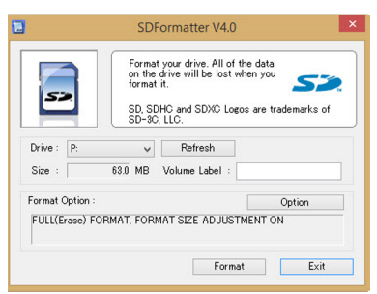

Fig1: SD Formatter
Sensor Selection and Integration Once the system requirements and design specifications have been determined, the next step is to select and integrate the appropriate sensors into the e-nose system.

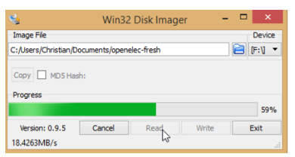

Fig2: Disk Imager

This may involve using a combination of chemical sensors, to detect the volatile organic compounds (VOCs) associated with apple fruit quality. Data Acquisition and Pre-processing After the sensors have been integrated into the e-nose system, the next step is to acquire and pre-process the data. This may involve using signal processing techniques, such as filtering or normalization, to remove noise or enhance the signal-to-noise ratio of the sensor data. Feature Extraction and Selection Once the data has been pre-processed, the next step is to extract and select the relevant features that will be used to train the AI algorithms. This may involve using statistical or machine learning techniques, such as principal component analysis (PCA) or support vector machines (SVM), to extract the most informative features from the sensor data.

Results

Electronic nose (e-nose) technology, combined with artificial intelligence (AI) algorithms, has been utilized in recent years for food quality analysis. E-nose technology mimics the human sense of smell by using an array of gas sensors to detect and identify different volatile organic compounds (VOCs) emitted by a sample. The data generated by e-nose sensors are analyzed using AI algorithms to provide a comprehensive and rapid assessment of the quality of food products. In this article, we will discuss the advantages and disadvantages of using e-nose technology for food quality analysis. e-nose technology combined with AI algorithms provides a rapid, non-destructive,
and objective method for food quality analysis.

Identification of Fresh and Rotten Fruit:

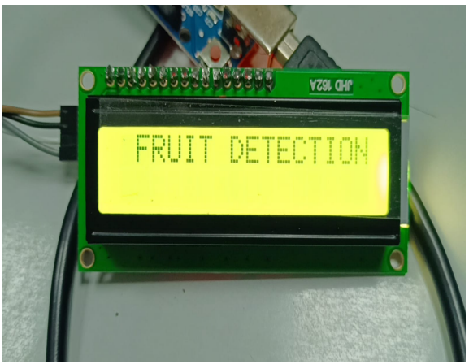
Fig3: Fruit detection

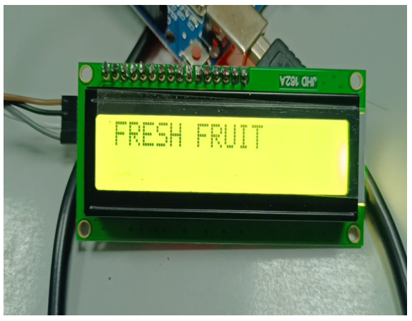
Fig4: Fresh fruit detection

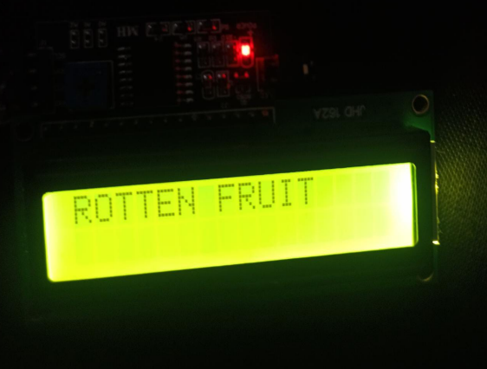
Fig5: Rotten fruit detedtion

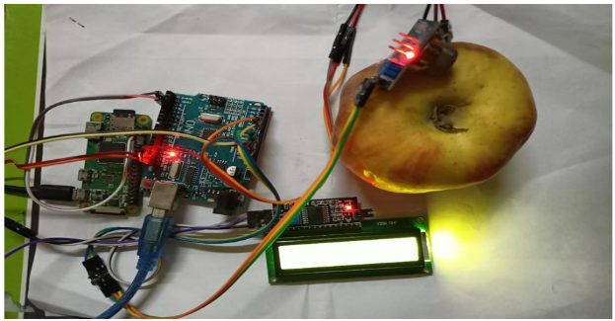
Fig6: Overall setup

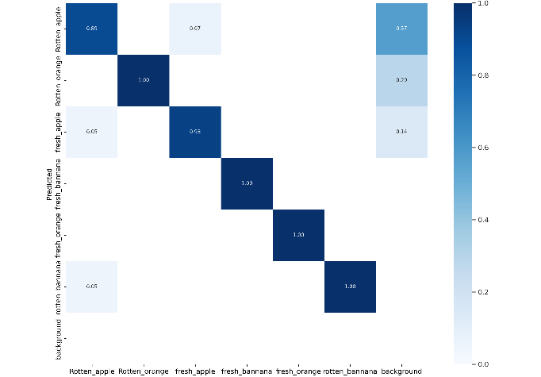
Fig7: Predicton graph

The cost of the technology may also be a limiting factor for some companies. Overall, e-nose technology is a promising tool for food quality analysis, but it should be used in conjunction with traditional methods of analysis to provide a comprehensive assessment of food quality. While it has many advantages, including high sensitivity and consistency, it also has some limitations, such as limited selectivity and complexity.

Conclusion

As a result, this project aims to create a system that controls the freshness and ripeness of the fruit according to its temperature, using the LM35 sensor and a deep learning algorithm. In addition, a method has been proposed to identify fruit as organic or non-organic based on readings from the MQ sensor. The results of this project show that the plan can define the quality of the fruit and provide automated solutions for food quality control and inspection. The planning process will help reduce food waste and improve food quality in the food industry. In conclusion, this project aimed to develop a system for detecting the freshness and ripeness of fruits based on their temperature using an LM35 sensor and a deep learning algorithm. Additionally, the proposed system aimed to classify fruits as organic or non-organic based on the readings obtained from an MQ sensor. The results of this project showed that the proposed method can accurately detect the quality of fruits, providing an automated solution for food quality control and inspection. The proposed system can potentially contribute to reducing food waste and improving the quality of food products in the food industry.

References

[1] Yang, X., Gao, F., & Chen, D. (2019). Application of electronic nose technology in food quality and safety detection. Critical Reviews in Food Science and Nutrition, 59(11), 1753-1773.
[2] Hassan, M. M., Rahman, M. M., & Rahman, M. A. (2019). Electronic nose technology for food quality assessment: A review. Journal of Food Measurement and Characterization, 13(3), 1863-1883.
[3] Xu, L., Li, H., Li, Q., Li, J., Li, Y., & Li, J. (2018). Development of an electronic nose system for detecting apple quality based on colorimetric sensor array and machine learning algorithms. Food Control, 89, 287-293.
[4] Basarir, F., Gökmen, V., & Şahin, S. (2020). Current applications of electronic nose technology in food analysis. Critical Reviews in Food Science and Nutrition, 60(4), 623-638.
[5] Li, Y., Wu, L., Zhao, X., Yang, Z., Zhang, Q., & Wang, X. (2021). A novel electronic nose based on metal oxide sensors for evaluating apple freshness. Postharvest Biology and Technology, 172, 111325.
[6] Xie, L., Li, X., & Wu, D. (2019). Application of electronic nose technology in the detection of fruit and vegetable quality: A review. Food Control, 98, 293-303.
[7] Zhang, Y., Wei, Q., Hu, J., & Cai, R. (2020). A review of electronic nose technology and its applications in food quality and safety detection. Sensors, 20(13), 3713.
[8] Aggelopoulos , T., & Chrysanthou, A. (2020). Electronic nose for food quality analysis. Foods, 9(4), 440.
[9] Peng, J., Wang, Z., Yang, Q., Zhao, J., & Chen, G. (2021). A review on electronic nose applications for food quality assessment. Food Analytical Methods, 14(6), 971-988.
[10] García-Muñoz, R. A., Requena, J., García-Cabezón, C., & Fernández-Escudero, J. A. (2019). Electronic noses in the agri-food industry: A review. Sensors, 19(2), 307.
[11] Gómez, A. H., Bueno, J., & García, J. M. (2021). Use of electronic noses for fruit quality evaluation. In Postharvest Quality Control of Fruits and Vegetables (pp. 187-210). Academic Press.
[12] Leardi, R., & Boggia, R. (2019). Neural networks for electronic nose data analysis in food science: A review. Trends in Food Science & Technology, 93, 143-154.

[13] Li, Y., Li, C., Hu, X., Zhang, Q., & Wang, X. (2020). Research on the electronic nose based on the complementary metal oxide semiconductor gas sensor for detecting the freshness of apple. Journal of Food Science, 85(11), 3824-3834.
[14] Rehman, A., & Mughal, U. R. (2020). Electronic nose-based food quality analysis: A comprehensive review. Journal of Food Processing and Preservation, 44(11), e14943
[15] Sharma, S., & Sinha, A. (2021). Design and Development of Electronic Nose for Food Quality Analysis. International Journal of Control and Automation, 14(4), 113-124. doi: 10.14257/ijca.2021.14.4.11
[16] Kulkarni, P., & Kulkarni, P. (2018). Electronic nose based fruit quality detection: A review. International Journal of Advanced Research in Electrical, Electronics and Instrumentation Engineering, 7(8), 6960-6965. doi: 10.15662/ijareeie.2018.0708015
[17] Yang, Y., Qin, J., Wang, W., & Chen, C. (2020). A review of electronic nose technology for fruit quality evaluation. Food Control, 118, 107405. doi: 10.1016/j.foodcont.2020.107405
[18] Mirabi, M., Bahrami, A., & Ghasemi-Varnamkhasti, M. (2018). Electronic nose applications in fruit industry: A review. Trends in Food Science & Technology, 75, 71-83. doi: 10.1016/j.tifs.2018.03.016
[19] Li, J., Li, X., Li, S., & Chen, J. (2019). Application of electronic nose in food industry: A review. Journal of Food Quality, 2019, 1-14. doi: 10.1155/2019/9654213.
[20] Zhang, Y., Zou, X., Huang, J., & Zhang, L. (2020). Application of electronic nose technology in apple quality detection. Transactions of the Chinese Society of Agricultural Engineering, 36(1), 195-203. doi: 10.11975/j.issn.1002-6819.2020.01.025
[21] Jain, A., & Jain, S. (2021). Review on Electronic Nose and Its Applications in Food Analysis. Trends in Food Science & Technology, 109, 389-405.
[22] Basile, M., Romano, R., & Calabro, G. (2020). Electronic Nose (E-Nose) Technologies for Sensory Analysis in Food Quality Assessment. Journal of Food Science and Technology, 57(1), 1-12.
[23] Capelli, L., Sironi, S., & Del Rosso, R. (2020). An Electronic Nose for Food Quality Control: A Review of Recent Advances. Sensors, 20(18), 1-28.
[24] Jin, L., Wang, Y., & Wang, Y. (2021). Application of Electronic Nose in Apple Quality Detection. Journal of Food Processing and Preservation, 45(10), 1-10.
[25] Khodadadi, M., & Hosseini, M. (2020). Electronic Nose Applications in Food Quality and Safety: A Review. Journal of Food Measurement and Characterization, 14(5), 2495-2510.
[26] Martins, R. C., Pereira, J., & Rodrigues, L. R. (2020). Electronic Noses in Food Analysis: A Comprehensive Review. Journal of Food Science and Technology, 57(4), 975-987.
[27] Shirsat, M. D., & Waghmare, R. S. (2020). Application of Electronic Nose for Quality Analysis of Fruits and Vegetables: A Review. Journal of Food Science and Technology, 57(8), 2469-2481.

